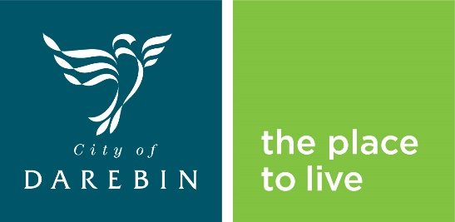

**Your Street, Your Say**

**Feedback Form**

**Group B- *Northcote East, Fairfield, Alphington, Thornbury East, Bundoora and Macleod***

First name*:

Last name*:

Address:

Postcode:

Email address:

About you

Your age: Choose an item.

Your gender: Choose an item.

Do you speak a language other than English at home? Yes No

If yes, which language(s)?

What is your connection to Darebin? Select all relevant.

Live Work Own a business  Study  Visit

Do you identify as Aboriginal and/or Torres Strait Islander? Yes No I prefer not to say

Do you identify as having a disability? Yes NoI prefer not to say

1. **Your details** (*please note, you must provide either your address or your email address for your feedback to be considered)

Please provide your feedback on the next page. *Indicates a response is required

4. Thinking more generally about this neighbourhood, what do you love and/or what changes do you want to make it better?

Thank you for providing your feedback. You can submit this feedback by emailing this form to [YourStreet.YourSay@darebin.vic.gov.au](mailto:YourStreet.YourSay@darebin.vic.gov.au) or by mailing it to PO Box 91, Preston VIC 3072.

*2. Please describe the location of the issue(s) including street name(s) and suburb

*3. Please describe the issue(s) you are experiencing at this location