JUNCTION URBAN MASTER PLAN
STAKEHOLDER ENGAGEMENT WORKSHOP

Outcomes of Consultation Report
Tuesday 29 October 2013

1. Introduction
The Junction is an inner city urban area that is rich in public transport infrastructure and located within close proximity to schools, parks, the Darebin Arts and Entertainment Centre and Ray Bramham Gardens. There are large established businesses in the precinct and some new and emerging smaller scale shops and cafes that are bringing a new energy and vitality to the area. All of these elements make the Junction an increasingly attractive inner urban centre.

Presently however, the Junction is not easy to walk or cycle around. It is situated between the heavily trafficked transport corridors of High Street and Plenty Road and suffers from significant traffic and parking problems. It is also a place with a diversity of built form from multi storey residential complexes to single storey industrial buildings, and lacks any coherent character. The area also suffers from a lack of pedestrian friendly street amenity such as landscaping, street furniture and weather shelter. This reflects the previous and recent use of the Junction as a place people pass through, as opposed to a place that is a destination for residents, workers and visitors.

2. History
Between 1999 and 2013 the Junction was a focus for significant planning work to increase development, business and private investment to the area. However, little effort was made to improve public space, amenity and urban character.

In 2013, engagement on Planning Scheme Amendment C137 Plenty Road corridor triggered interest in the quality of public space in the Junction. This led to a resolution by Darebin Council on 7 October 2013 to:

Develop a draft Junction Urban Master Plan incorporating streetscape improvements, traffic management and parking improvements and improvements to the pedestrian and bicycle environments.

A further resolution was made that a draft Junction Urban Master Plan be prepared for community consultation in December 2013.

Council appointed Cardno to prepare a Transport Study of the Junction to inform the management of traffic and car parking in the area into the future. Outlines Landscape Architecture was also appointed to help prepare the draft Junction Urban Master Plan.

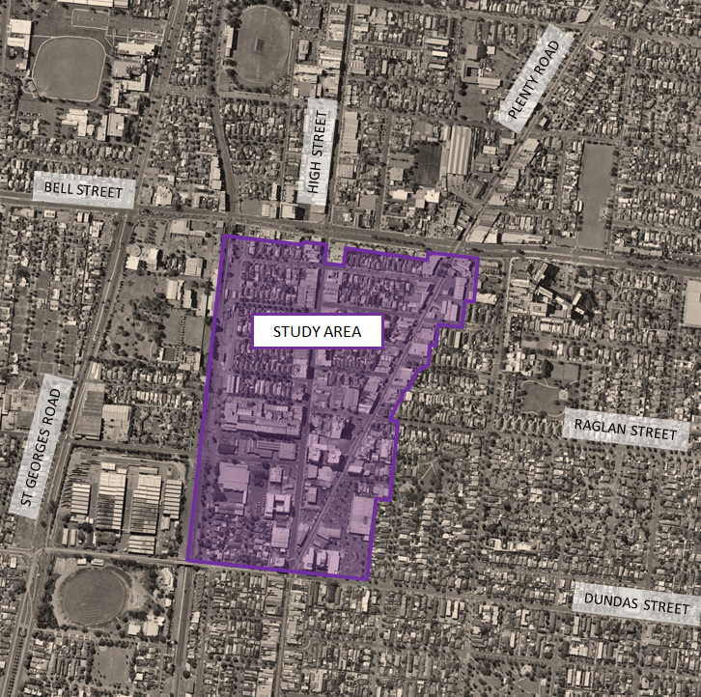
Map of the Junction Precinct (study area) and surrounds

3. Consultation
Council held a series of consultations between August and September to build local knowledge about land use issues in the Junction. These consultations included semi structured interviews with residents and businesses to identify issues and opportunities to improve public space to support cultural development, economic development and branding identity for local businesses.

A workshop was held with residents and key stakeholders on Tuesday 29 October from 5.30pm – 8.30pm at Buddha Thai Restaurant in Plenty Road to gain input into the draft Junction Urban Master Plan.

The objectives of the Junction Urban Master Plan Stakeholder Engagement Workshop were to:
- Understand how the Junction is currently used by local residents, businesses and visitors
- Brainstorm opportunities for improving the quality of public space at the Junction.

Three activities were held with participants as part of the workshop. The first activity aimed to engage participants on the topic of how they carry out their everyday activities at the Junction. Aerial maps of the Junction were provided with tracing paper and groups were invited to draw on the map to provide information about what areas of the Junction operate well and which ones do not.

Residents plotted their experiences in relation to the following questions:
- How do you go to the shops? If you don’t shop in the Junction, why not?

- Do you access any schools or facilities in the area? How do you get there? What do you like? What don’t you like?

- Do you use public transport? If so, what is your experience walking to the tram stop on High Street, Bell Train Station, the bus stop? What is your experience using public transport in the Junction?

- Where are the areas where people congregate?

- Where are the main crossing points on roads?

- What areas feel safe and which ones do not feel safe and why?

- Where does traffic build up? Are there any roads or areas that feel unsafe?

In the second activity, participants were asked to use photo images and their own ideas to discuss ‘what creates a good sense of place’, and what helps a place develop a distinct urban character. Groups were encouraged to have a discussion about what improvements could be made to public areas to enhance a sense of urban character at the Junction.

The following questions were used to prompt discussions:
- What specific features make an area attractive?

- Consider a place with a distinct urban character – What creates its sense of place? Be specific.

- What is the emerging character of the Junction?

The final activity of the evening involved participants consolidating their ideas by capturing key points and displaying them on a wall in the restaurant. Groups were also invited to comment on what they thought should be the highest priorities of the draft Junction Urban Master Plan.

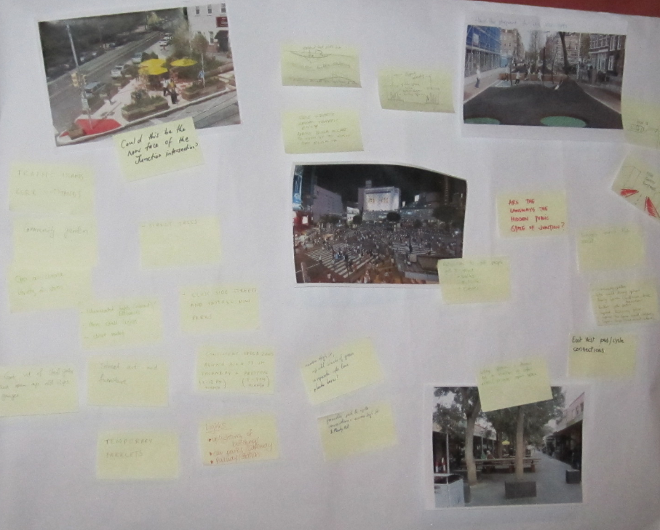

Photo of resident ideas displayed on a wall at the Junction Urban Master Plan Stakeholder Engagement Workshop
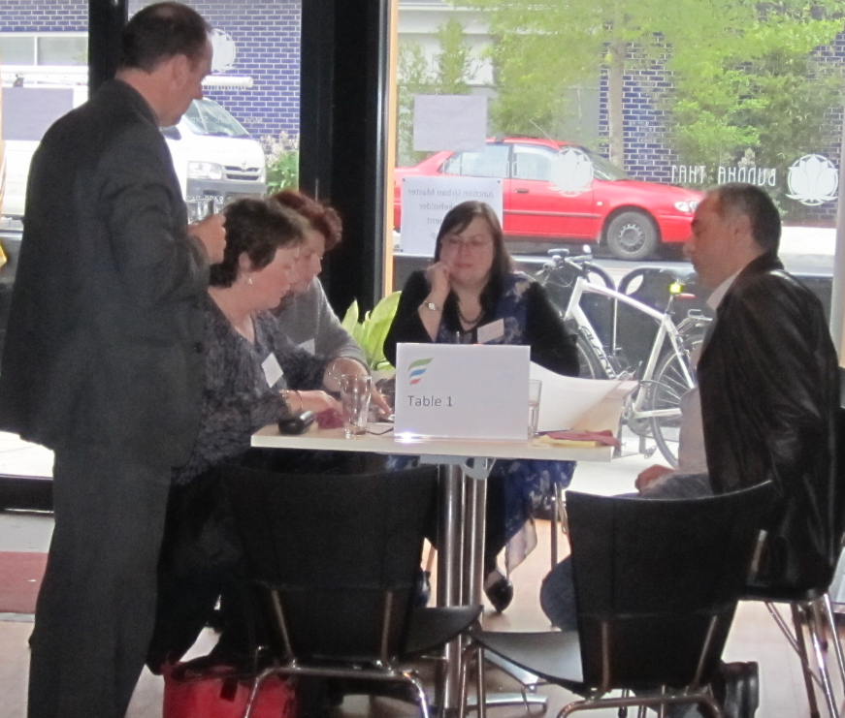

Darebin Councillor Vince Fontana, Darebin staff and residents identify priority areas for the draft Junction Urban Master Plan
4. Community Feedback

4.1 Summary of issues
Residents and businesses reflected on their personal experiences of using the Junction and provided a wide range of feedback. This feedback is categorised below in themes and reported in community member’s own words:

Make areas friendly for pedestrians and cyclists
- High Street is not a pleasant place to either walk or ride a bike. It could benefit from trees that provide shade, and more activity on the street.

- The shops require some awnings to provide weather protection. Bike racks outside shops could be of use also.

- Could the road on High Street allow for more shared space so that cyclists, pedestrians and cars have a share of the space? Is it possible to create more crossing points on High Street so that pedestrians can move around more freely?

- Plenty Road is being revitalised by the tram but it is not nice to walk down. What is the identity of Plenty Road? What does it want to be?

- Oakover Road is a busy street that is not easily walkable.

- It takes too long to cross the intersection of High Street, Plenty Road and Dundas Street. What can be done with this intersection to make it friendlier for pedestrians?

- Common destinations near the Junction include the Preston Market, which people mostly travel to via High Street. There is a medical clinic on Bell Street near Bell City and there is a Video Ezy on High Street. The park behind Safeway is one that is used occasionally by families but is not easy to access and perceived as being unsafe.

- High Street is a key route for pedestrians although presently, it is not a nice place to walk. There are poor pedestrian links between High Street and Plenty Road and the lights at intersections take too long.

- To walk or cycle, the intersection of Adeline Street and High Street is a nightmare ‘Death crossing’.

- Walkability along Plenty Road is poor with poor quality pedestrian crossing points, and lights taking too long to enable safe crossing.

- People often take the tram south down Plenty Road to go to the city, or travel down High Street to enjoy food, theatre and friends. The Junction is not yet a destination for these activities.

- It is difficult to cross between High Street and Plenty Road. How can we create more pathways through the space? We need a passage through the Junction Hotel car park, and potentially other places.

- People drive too fast on Milton Crescent, and in the Safeway car park. Can we slow down the cars or provide for more shared space?

- Can we reallocate road space to allow more shared space on High Street?

- The pedestrian crossing at the corner of High Street and Gertrude Street needs to be addressed to feel more safe.

Create places for interaction in the Junction
- What options are there for incorporating some public open space in the Junction? Would it be possible to have some public open space at the edge of the Safeway car park facing on to Plenty Road?

- We need more lighting in parks

- Can we create some more spaces for interaction in the Junction?

- Can we create a park in the Aldi car park? Or transform the enclosed areas around Safeway into a piazza?

Better connect the Junction to other places
- There are public safety issues in the park behind Milton Crescent. Syringes are often found in the park. Residents typically do not use the park much because of this. However the Park is within close proximity to the Safeway car park.

- How can we integrate Bell Train Station with the precinct? Can we revitalise the VicTrack land near the train station or use it for public space? There used to be an old bike track along railway line which could be revitalised. This potential bike path could create an alternative option to St Georges Road cycle path.

- There are no clear or easily walkable passages through the precinct to Bell Train Station. Also, bikes are regularly stolen from the Train Station. Is there any way to make these places safer for cyclists?

- There is a lot of open space in the Junction, but it is not well connected to other parts of the precinct

- Can we connect the park behind Safeway to other areas?

- There are no clear connections to Ray Bramham gardens. No signage or wayfinding.

- The whole precinct is a central point to surrounding areas and could benefit from wayfinding signage

- There is a lack of walkable passageways through to Ray Bramham gardens

Safety and perceptions of safety:
- Places avoided at night or that have a negative perception of safety include:
  - The corner of Railway Place and Showers Street
  - The corner of Railway Place and Adeline Street
  - Safeway car park
  - The park behind Safeway car park
  - Yann Street
  - The corner of Gertrude Street and High Street. Trees block out light on the street
  - Garnet Street is a dark street at night with a strange laneway section that feels unsafe
  - Oakover Road is a street that is avoided. Oakover Road is tight, dark and bleak

- Garnet Street is a cut through area because people don’t want to use the main intersection at Bell Street. Therefore Garnet Street is a rat run.

- We avoid the High Street/Bell Street intersection. It’s too unsafe.

- Gertrude Street is blocked off somewhat, so traffic often passes through smaller streets. They are becoming a rat run for cars.

- We avoid Oakover Road as it is too busy and too much of a rat run so we use Showers Street to cut through the Junction on bike or by foot.

- Often we cycle over the crossover on Railway Place to cut through to St Georges Road but generally Railway Place feels unsafe.

4.2 Creative ideas for revitalising the Junction
Members of the community brainstormed a variety of ideas for improving the quality and functionality of public space in the Junction. Below is a raw account of ideas that came out of the workshop, in the community’s own words and pictures:
- Could we have roof top planter boxes and balcony planter boxes to green areas of the Junction?

- Could developers make a contribution to enable us to have more street trees?

- We want more shops and destinations in the Junction

- There are no financial banks in the Junction. The centre could benefit from having banks and easy access to money

- Use creative curvilinear traffic calming

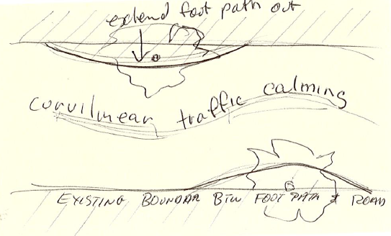

A resident’s drawing of possible curvilinear traffic calming on High Street to slow traffic and create more public space

- Better lighting at the Junction is needed

- We need places for shade, and greener spaces in the Junction

- Rethink High Street to create a boulevard for pedestrians, or a boulevard idea along the Bell Station Railway Line

- Community gardens can create places for interaction

- Improve interaction points between shops, facades and pedestrians

- Connectivity could be improved

- Better footpaths

- Can we make the area more people friendly, liveable, more life on the street, interaction between pedestrians, buildings, shop fronts, cafes?

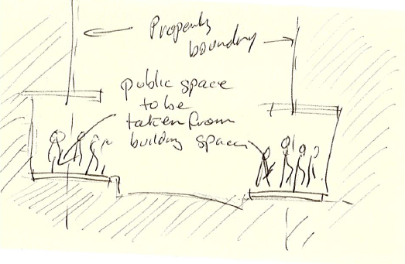
A resident’s drawing of how public space might be incorporated into private space

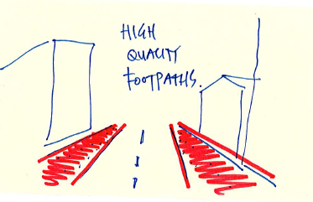
A resident’s drawing of how quality footpaths might look in the Junction

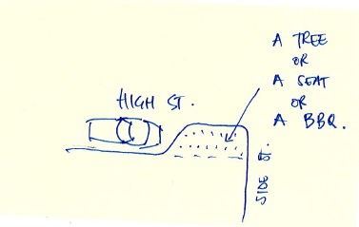

A resident’s drawing of how public space might be incorporated into space typically allocated to cars

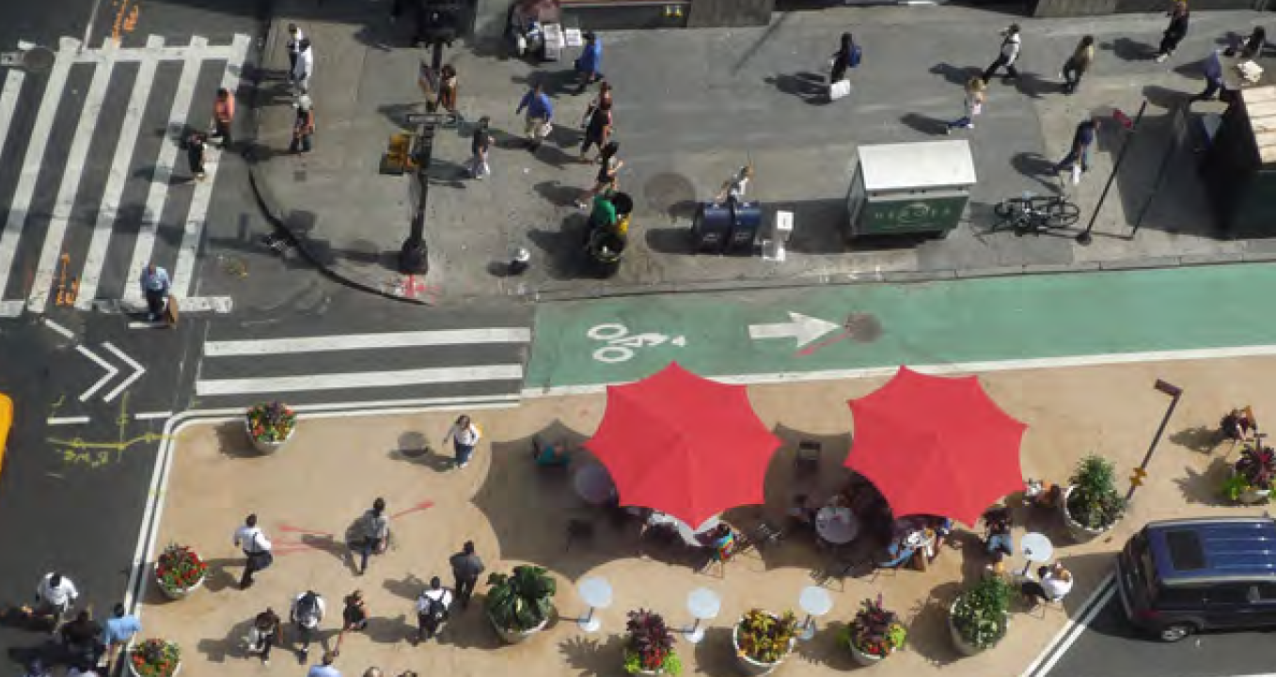

This photo image was used to further illustrate a resident’s idea of incorporating public space onto a road
Source: Image supplied by Outlines Landscape Architecture

- Priority for pedestrians and cyclists – especially at crossing points

- Incorporate mosaic art in the landscape, yarn bombing poles, interesting things for kids to look at, lots of trees, no more residential flats please!

- Wayfinding signs (to Bell Station and Northland?)

- Give me a reason to stop and enjoy the Junction!

- Use uplighting on buildings to create attractive features in the landscape

- Street art and furniture is needed in the Junction
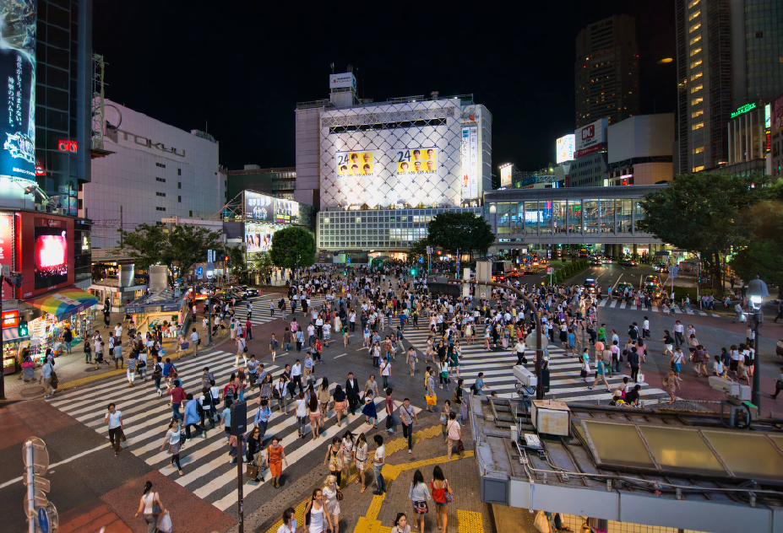
This photo was used demonstrate how the intersection of Plenty Road, High Street and Dundas Street might be transformed to enable a pedestrian scramble.
Source: Image supplied by Outlines Landscape Architecture

- Get rid of steel gates on Plenty Road and High Street and open up old shops and garages

- Provide a variety of businesses that are affordable and exciting for residents

- Can we have an open air cinema in the Junction?

- Provide for a variety of stores

- Traffic islands

- Kerb outstands

- Street festivals

- Attract more health services in the catchment such as dental services and 24 hour doctors

- Use illuminated lights to make billboards more vibrant, especially at the Plenty Road and High Street intersection. This place could be transformed into a miniature version of Times Square

- More street lights

- Street seating

- Consistent speed zones along High Street in Thornbury and Preston (8-12 AM 40km per hour) and (7-7PM 40 km per hour)

- Street art and furniture

- Make High Street a more narrow space for cars. Add islands of green, separate cycle lanes and planter boxes

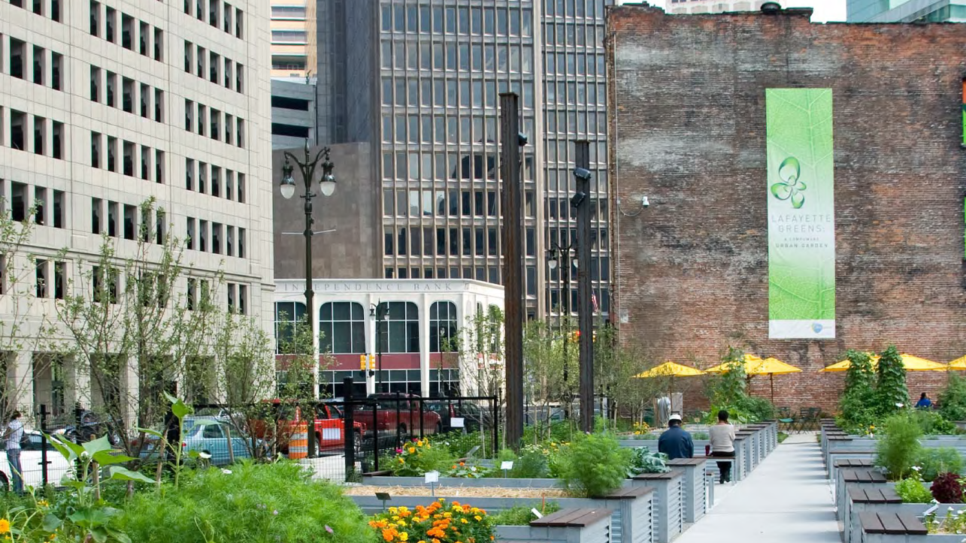
This photo was presented by a resident to suggest how community gardens might be incorporated into an urban context
Source: Image supplied by Outlines Landscape Architecture
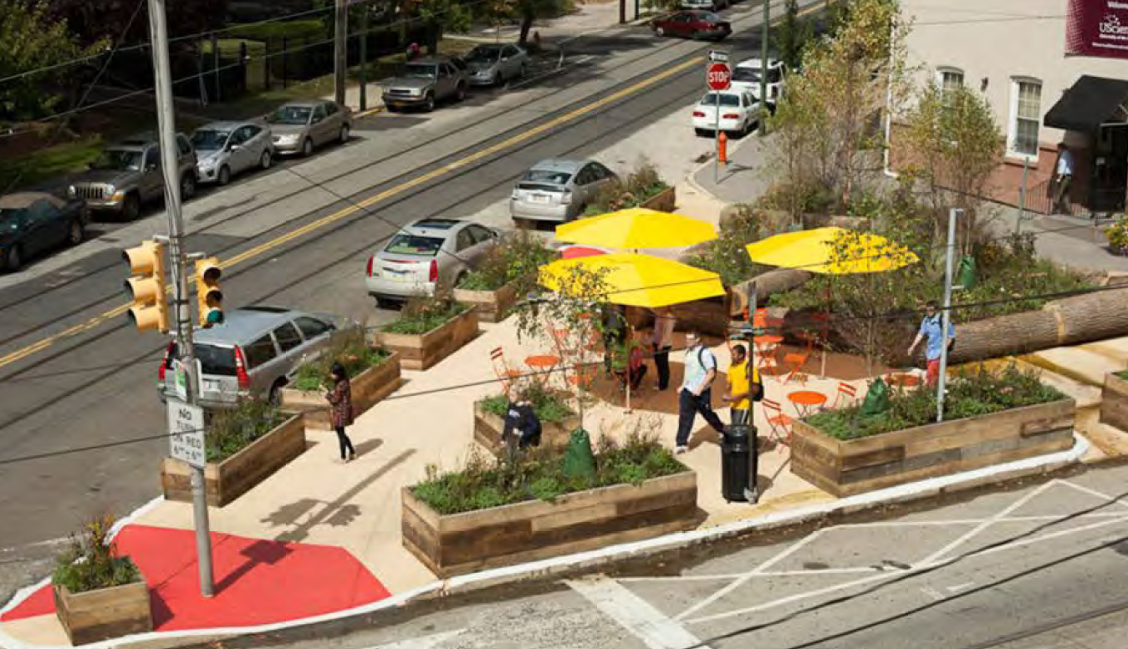
A resident used this photo to support the idea of incorporating public space outside the Junction Hotel at the corner of Plenty Road, High Street and Dundas Street
Source: Image supplied by Outlines Landscape Architecture

- Match traffic speed limits and times

- Formalise pedestrian and cycle connections across High Street and Plenty Road

- Provide tall and shady trees

- Local traffic only in side streets, partly block access to High Street to limit the rat running

- Are the laneways the hidden public space of the Junction?

- Make the Junction Hotel more attractive as a focal point

- Increase pedestrian linkages across High Street

- Promote and market businesses in the Junction via social media

- Improve cycling connections east to west across the Junction

- Have activities to get people out and about such as walks, activities and events

- Community gardens

- Provide late night dining options

- Create family spaces, landscapes, picnics and activities

- Improve the quality of cycling paths

- Improve Railway Place

- Improve the spaces and shops around Safeway

- The Junction needs more sitting spaces. It would be good to have areas that are shared by a number of different cafes. Link public and private open space

- Can we have high quality footpaths?

- Connect streets to green spaces and parks

- Can we have trees, seats and barbecues on High Street?

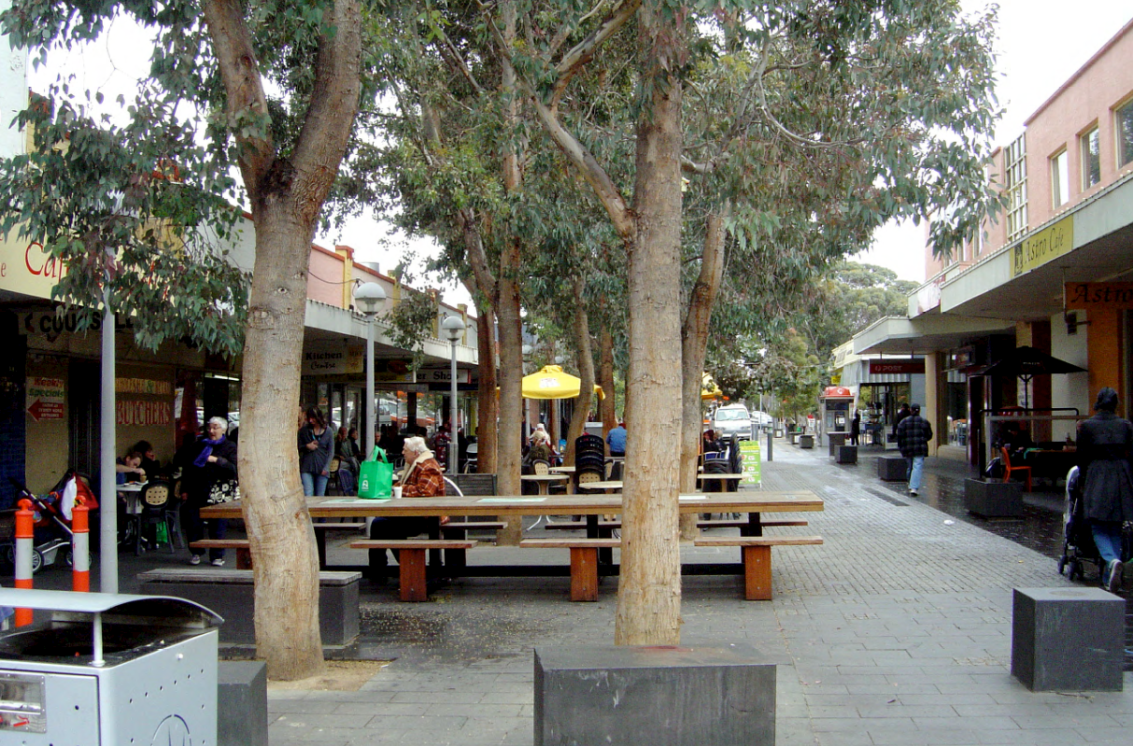

This image was used by a resident to suggest how shaded, shared spaces can be incorporated in the urban landscape to support a range of businesses
Source: Image supplied by Outlines Landscape Architecture
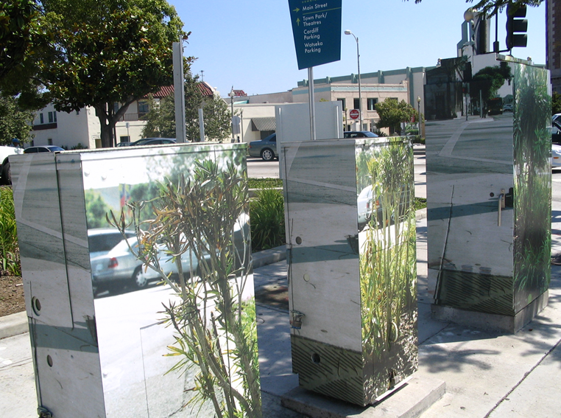

A resident provided this image to explain how public art could be subtly incorporated into the landscape at the Junction to contribute to a distinct urban character
Source: Image supplied by Creative Culture department, City of Darebin

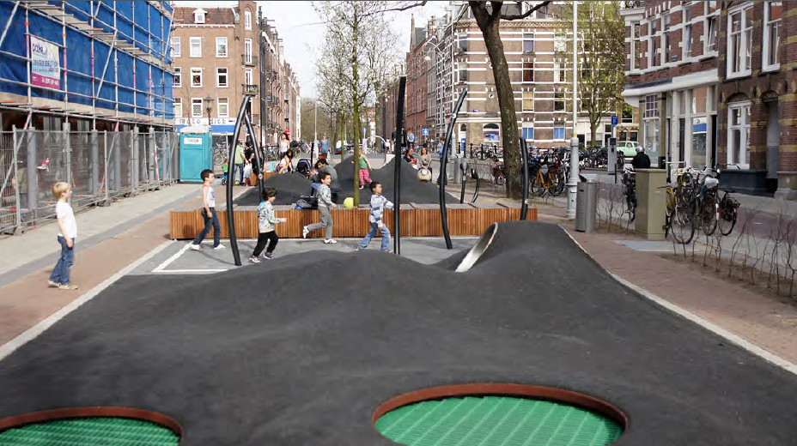
This photo image was used by a resident to demonstrate how quality playgrounds can be incorporated into reasonably dense urban areas such as the Junction.
Source: Image supplied by Outlines Landscape Architecture

4.3 Perceived priorities
Participants were invited to comment on what they thought should be the key priorities of the draft Junction Urban Master Plan. The community identified the following themes in order of priority:

- Encourage walking and cycling
- Improve street amenity for pedestrians
- Create places for social interaction
- Make the Junction green and attractive
- Encourage local business and activity on the street
- Create opportunities for public art and creative culture

5. Discussion
Participants at the Stakeholder Engagement Workshop contributed a broad spectrum of ideas for improving the quality of public space in the Junction. Key suggestions were to strengthen connectivity and wayfinding at the Junction; improve streetscape amenity particularly along High Street and Plenty Road to support pedestrians and cyclists; increase the mix of local businesses in the area; and provide spaces for interaction and lighting in streets to encourage a night life in the area. Participants were also keen to see Council improve area amenity to encourage a distinct sense of urban character, in particular through the use of landscaping treatments and by providing quality pedestrian amenity in key areas.

6. Conclusion and future actions
The Stakeholder Engagement Workshop provided valuable local knowledge about the Junction Precinct as well as ideas to improve the quality of public space in the area. The ideas raised at the Junction Urban Master Plan Stakeholder Engagement Workshop will be incorporated into the draft Junction Urban Master Plan.

A draft of the Junction Urban Master Plan will be produced in late November and made available for public viewing and feedback in the first two weeks of December. A flyer about the Draft Junction Urban Master Plan will be distributed to households and businesses in the precinct in early December and information will be made available on the Darebin Your Say website. Members of the local community will be able to provide feedback on the draft Junction Urban Master Plan via an online survey.

In early 2014 community feedback on the draft Plan will be incorporated into a revised version of the draft Junction Urban Master Plan, and the Plan will be presented to Council at a meeting in early 2014. Following this date Council staff will progress implementation of the Plan over a ten year period by way of capital funding and potential developer contributions.

Now branded as Woolworths, but locally referred to as Safeway

