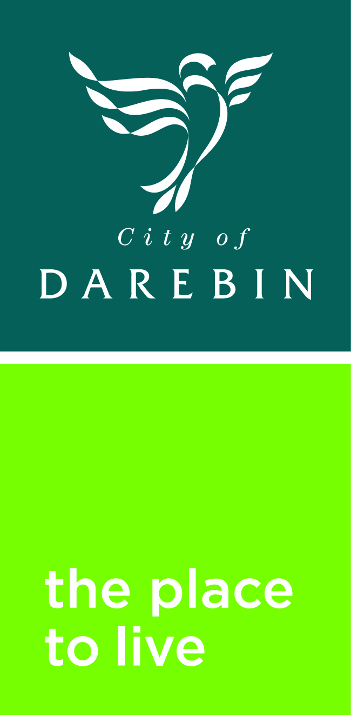

Darebin City Council
Northcote Aquatic and Recreation Centre

Concept Designs Feedback Survey

We are excited to share with you the concept designs for the proposed renewal of Northcote Aquatic and Recreation Centre (NARC)

You’re invited to participate in this important stage of the process by providing your feedback.

We want to know how you would use and experience the facility, based on the proposed plans presented on the Your Say Page https://www.yoursaydarebin.com.au/NARC

Privacy Statement - The information collected from this survey will only be used for the purpose of reviewing the concept plans for the Northcote Aquatic and Recreation Centre as part of the design process.

This survey closes on 3rd May 2020

Please return to - Darebin City Council, Attention: Leisure Major Projects Officer, 274 Gower Street Preston 3072

To answer the questions, please tick your response. 

From looking at the facility plans for the proposed new Northcote Aquatic and Recreation Centre please respond to the following questions:

Q1. Overall, how would you rate the proposed design for the new NARC facility? (Tick only one response):

Very Poor (can you please explain)  Good (GO TO Q2) 
Poor (can you please explain)  Excellent (GO TO Q2) 
Neutral (GO TO Q2) 

Q2. Looking at the artist’s impressions of the building do you think it will fit in with the local neighbourhood?

Yes (GO TO Q3)  No (Can you please explain) 

Q3. Council is aiming to develop the facility with a 6 Star Green Star Rating

Council is committed to addressing the Climate Emergency and adopted the ESD Policy in 2018 to inform environmental goals and responsibilities for future projects.
NARC is striving to become the first indoor aquatic facility in Australia to reach a 6 Star Green Star Rating. Launched by the Green Building Council of Australia in 2003, Green Star is Australia's only national and voluntary rating system for buildings and communities.
A building with this rating is assessed on sustainable design, construction and operation and fit out.

These proposed plans include a number of environmentally sustainable design initiatives which may have a higher capital expenditure cost, but lower operating cost over the Lifecyle of the building. Do you support this objective?

Yes (GO TO Q4)  No (Can you please explain) 

Q4. Based on the proposed plans you have viewed; do you think you will use the new Northcote Aquatic and Recreation Centre?

Yes (GO TO Q5)  No (GO TO QUESTION 11) 

Q5. Why will you choose to use this facility? (Please tick up to 3 responses) (Tick box next to your responses)

Close to home  To attend health and fitness program 
Close to work/school  To attend leisure water/fun pools 
Friends/Family use it  To attend learn to swim program 
Good facilities  Close to public transport 
It has an indoor pool  Accessible facility 
To attend aquatic program  To use the outdoor pool 
To use the leisure /aqua play areas  Other (Please specify) 
To use the program pool  
To use warm water pool for therapy

Q6. What are the main activities you think you will do at the new facility? (Please tick up to 3 responses)

Lap swimming in Indoor pool  Use the gym/weights room 
Aquaerobics  Group health and fitness activities 
Competition swimming activities (swim club)  Participate in the spin classes 
Cool down from hot weather  Use the reformer pilates facilities 
Recreation swimming/fun  Use the health suites i.e. physiotherapist etc 
Learn to swim classes  Use the sauna / spa 
Aquatic rehabilitation / therapy activity  Meet with friends 
Personal training  To use the meeting/program rooms 
Use the leisure / aqua play area  To participate in an event 
Take part in aquatic program  Use the childcare area 
Lap swimming in the outdoor 50m pool  Tennis activities 
Water based fitness activity  Other (Please specify) 
Take child to the pool  

Q7. Do you think the facility layout (location of the components) will make it easy for you to make use of the facilities you have chosen?

Yes (GO TO Q8)  No (Can you please explain) 

Q8. What time do you think you would generally use the new facility? (Please tick one response only)

Before 9.00am  2.00pm to 5.00pm 
9.00am to 12 midday  5.00pm to 8.00pm 
Midday to 2.00pm  After 8.00pm 

Q9. What would your primary mode of transport be to get to NARC? (Please tick one response only)

Bike  Taxi 
Bus  Train 
Car (on own)  Walk 
Car (with others)  Other (Please specify) 

Q10. How frequently will you visit NARC?

Daily  Once a fortnight 
4 to 6 times a week  Once a month 
2 to 3 times a week  Less than once a month 
Weekly  Summer only 

Q11. If you don’t think you will use the new NARC can you please tell us why? (Please choose up to 3 responses) (Tick box next to your responses)

Activity not available  I am too busy to use the facilities 
Can’t swim  No one to go with 
Facilities don’t suit my needs  Not a club member 
Cultural beliefs restrict use  Not interested 
Don’t know what is available  Not value for money 
Don’t know  I am too old to use the facilities 
Don’t like swimming  Transport problems 
Family commitments  Work commitments 
Go to the beach  Use neighbours/friends pool 
Have and use own pool  Cannot afford it 
Health problems  Other (Can you please explain) 
Lack of information 
Language difficulties 

Q12. Do you have any other comments about the proposed new Northcote Aquatic and Recreation Centre?

The following questions are for us to understand more about you.

Q12. What is your gender?

Male  Female 
Prefer not to specify  I identify as (Please specify) 

Q13. Which age group are you in?

10 years and under  40 to 49 years 
11 to 19 years  50 to 59 years 
20 to 29 years  60 to 69 years 
30 to 39 years  70 years plus 
Prefer not to say 

If you are under 16 years of age, please make sure you let your guardian or parent know you are completing this survey.

Q14. Please specify the language(s) spoken at home.

English  Vietnamese 
Greek  Macedonian 
Mandarin  Cantonese 
Arabic  Hindi 
Punjabi  Spanish 
Other (Please specify) 

Q15 Are you Aboriginal and/or Torres Strait Islander origin?

Yes - Aboriginal 
Yes - Torres Strait Islander 
Yes – Aboriginal and Torres Strait Islander 
No 
Prefer not to say 

Q16. What is your postcode?

3070 (Northcote)  3078 (Alphington/Fairfield) 
3071 (Thornbury)  3083 (Bundoora/Kingsbury) 
3072 (Preston)  3085 (Macleod) 
3073 (Reservoir)  Other (Please specify) 

Thank you for your assistance!

