Media Release
12 August 2021

Darebin Council commissions major new artwork

Darebin Council is thrilled to announce a major new integrated art commission has been awarded to esteemed Melbourne artist Esther Stewart.

Following a competitive tender process, Stewart has been commissioned to design and develop two significant artworks at the soon-to-be-completed Narrandjeri Stadium, located in John Cain Memorial Park, Thornbury.

Narrandjeri Stadium (which means “Women Leader” in Woi wurrung language) is a purpose-built premier facility for women’s sport. The stadium will feature four indoor courts for a range of sports such as netball, basketball, badminton, volleyball and roller derby and will be a 5-star Green Star certified building. Narrandjeri Stadium will lead the way in demonstrating the value and positive intersections of public art, architecture and construction in the municipality.

Stewart will design and develop a permanent integrated artwork to the large bank of glass window areas at the Narrandjeri Stadium entry and café, as well as a large-scale wall-based artwork to be displayed in the interior foyer space.

Stewart is considered one of Australia’s leading contemporary artists. She was born in Katherine in the Northern Territory in 1988 and now works between Melbourne and Daylesford, Victoria. Stewart has completed a Masters of Cultural and Arts Management, University of Melbourne and a Bachelor of Fine Arts – Honours at the Victorian Collection of the Arts, and is currently undertaking a Masters of Architecture, University of Melbourne.

Her work explores architecture, civic and domestic spaces through the dimension of abstraction. Using visual languages of repetition and composition through colour and line, Stewart’s practice investigates the
boundaries between non–representation and representation, and the ideas of both contemporary and historic urbanism and domestication.

In recent years Stewart has undertaken significant exhibitions and commissions both nationally and internationally, including partnerships with Valentino fashion house, Bendigo Hospital, Victoria, the Galleria Dell Accadmeia in Florence, Italy, and Heide Museum of Modern Art, Melbourne. Darebin Council looks forward to working with her on this important art project. This artwork commission for Narrandjeri Stadium is being supported by Consultant Curator Lisa Warrener of Global Art Projects.

Over the last 25 years, the City of Darebin has earned an impressive reputation for enhancing its urban landscape with innovative art projects and initiatives. In line with this commitment, the City of Darebin encourages opportunities to engage artists in its own Capital Works and Civic Building projects. As part of its Creative and Cultural Infrastructure Framework (2018), Council has committed to involve artists in construction projects over a certain scale or budget. Narrandjeri Stadium is the latest project of this nature.

Designed by Brand Architects, Narrandjeri Stadium commenced construction in September 2020 and is planned to be completed in December 2021.

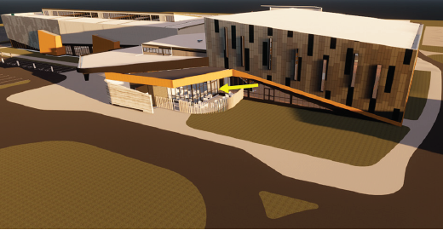

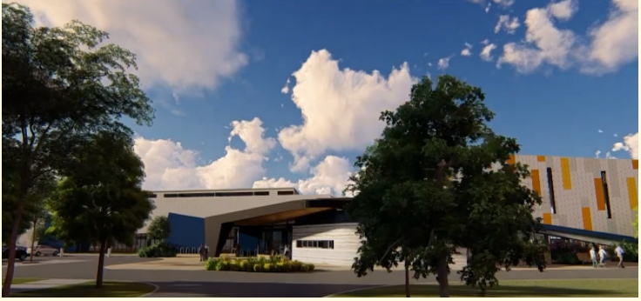

Images: Top: Portrait of Esther Stewart in her studio. Courtesy of the artist. Photograph by Lauren Bamford.
Middle and bottom: Artist drawings of Narrandjeri Stadium which is currently under construction at John Cain Memorial Park in Thornbury

