Planning and Environment Act 1987

DAREBIN PLANNING SCHEME AMENDMENT C191dare EXPLANATORY REPORT
Who is the planning authority?

This amendment has been prepared by the Darebin City Council, who is the planning authority for this amendment.
The amendment has been made at the request of Darebin City Council.

Land affected by the amendment

The amendment applies to 599 properties in Thornbury, as shown in Map 1, which together form a precinct referred to as the Thornbury Park Estate.

The amendment applies to individual properties at the following addresses:

- 29A - 43 and 55 - 67 Comas Grove, Thornbury and 34 – 64 Comas Grove, Thornbury
- 59 – 107 Fyffe Street, Thornbury and 60 – 108 Fyffe Street, Thornbury
- 133 – 177 Harold Street, Thornbury and 164 – 214 Harold Street, Thornbury
- 2B and 2CHill Street Thornbury
- 19 and 25 Hobson St, Thornbury
- 108- 158 Hutton St, Thornbury and 145A-197 Hutton St, Thornbury
- 1A – 117 Keon St, Thornbury and 2-128 Keon St, Thornbury
- 21 -187 Miller St, Thornbury
- 1 -135 Rennie St, Thornbury and 2A -106 Rennie St, Thornbury
- 152-192 Smith St, Thornbury
- 1-19 Taylor St, Thornbury and 2-8 Taylor St, Thornbury

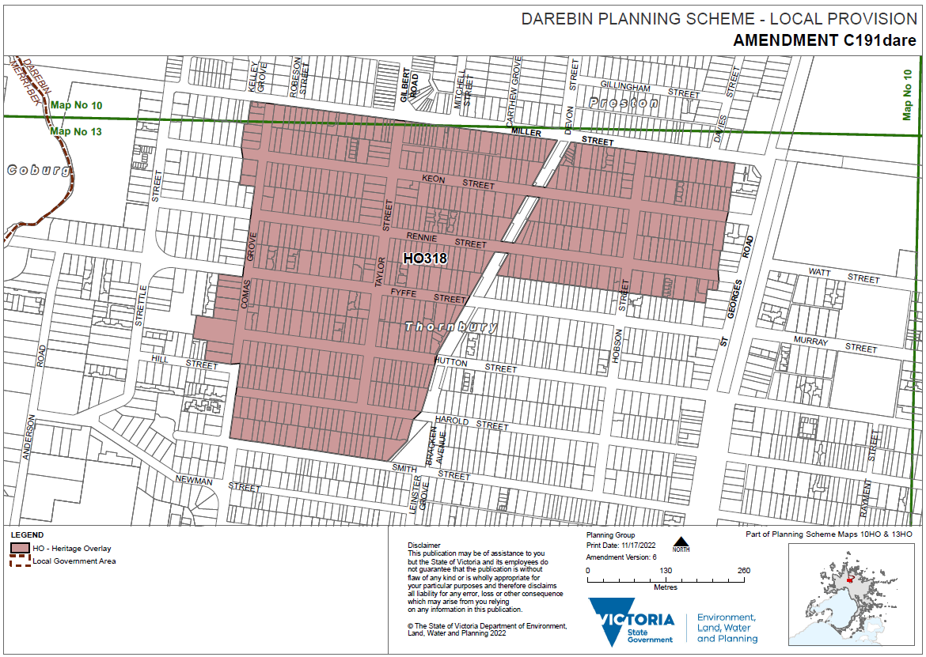Map 1 –Darebin C191 Part of Map10HO and 13HO Exhibition

What the amendment does

The Amendment proposes to implement the recommendations of the Thornbury Park Estate Precinct (RBA Architects and Conservation Consultants, 2022) by applying the Heritage Overlay (HO318) to Thornbury Park Estate heritage precinct.

Specifically, the Amendment makes the following changes to the Darebin Planning Scheme:
- Amends the Schedule to Clause 43.01 (Heritage Overlay) and Planning Scheme Map 10HO and 13HO to apply the Heritage Overlay (HO318) to land within the Thornbury Park Estate precinct, and to remove the interim Heritage Overlay (where not removed earlier from land within the Estate not proposed for permanent heritage controls).

- Amends the Schedule to Clause 72.04 (Documents Incorporated in this Planning Scheme) to include the updated incorporated document City of Darebin heritage study Incorporated Plan – Permit exemptions (2022) and include Thornbury Park Estate Precinct Statement of Significance, 2022.

- Amends the Schedule to Clause 72.08 (Background documents) to reference Thornbury Park Estate Precinct (RBA Architects and Conservation Consultants, 2022)
Strategic assessment of the Amendment

Why is the Amendment required?

In accordance with the Planning Policy Framework (PPF), it is State policy to ensure the conservation of heritage significant places. To do this, places, buildings and objects must be identified, assessed and documented as places of natural and cultural heritage significance, as a basis for their inclusion in Victorian planning schemes.

Darebin City Council has an obligation to conserve and protect Darebin’s cultural and built heritage. To do this Council undertakes heritage reviews and gap studies to investigate the significance of place and the appropriateness of their protection via a Heritage Overlay, and subsequent inclusion in the Darebin Planning Scheme. This is consistent with the Darebin Council Plan (2021-2025) to protect valued neighbourhood character. The planning scheme is the most appropriate means of protecting heritage places and achieving the desired outcome.
The amendment proposes to implement the recommendations of the Thornbury Park Estate Precinct (RBA Architects and Conservation Consultants, 2022). This study provides strategic justification to support the amendment. The desired outcome will be to formally protect places of local heritage significance in the Darebin Planning Scheme and ensure new development, whether contributory or non-contributory dwelling, does not affect the significance of the heritage precinct/place. This aligns with the purpose of the Heritage Overlay.
The amendment will ensure that a planning permit is required for demolition and a range of buildings and works to ensure the heritage significance is protected. Any proposal will then be able to be assessed by Council having regard to the purpose and decision guidelines of the Planning Policy Framework and Heritage Overlay. Planning permit exemptions for minor works not deemed to impact the heritage values are outlined in the City of Darebin Heritage study Incorporated Plan – Permit exemptions (2022)
Various structural improvements were made to the Schedule to the Heritage Overlay as part of Amendment VC148. These changes enable a statement of significance to be listed and incorporated to assist decision making.
The amendment makes use of these new provisions by listing the Thornbury Park Estate Precinct Statement of Significance, 2022 in the Schedule to the Heritage Overlay and incorporating the document in the Schedule to Clause 72.04.

How does the Amendment implement the objectives of planning in Victoria?

The amendment implements the following objectives of planning in Victoria, under Section 4 of the
Planning and Environment Act 1987:

- To provide for the fair, orderly, economic and sustainable use, and development of land.
- To conserve and enhance those buildings, areas or other places which are of scientific, aesthetic, architectural or historical interest, or otherwise of special cultural value.
- To balance the present and future interests of all Victorians.
- To secure a pleasant, efficient and safe working, living and recreational environmental for all Victorians and visitors to Victoria
- To facilitate development in accordance with the objectives outlined above.

The amendment implements these objectives by applying the Heritage Overlay to the Thornbury Park Estate heritage precinct to protect heritage places in the City of Darebin.

How does the Amendment address any environmental, social and economic effects?

The amendment is expected to have a positive environmental impact by protecting places of historic significance and thereby supporting the reuse of existing building stock.

The amendment is also expected to have positive social effects by ensuring future development responds to the heritage significance of the precinct, so it can be appreciated by future generations.

The amendment is not expected to have significant economic impacts, although it may impose some additional costs on the owners or developers of affected properties as a planning permit will be required for most buildings and works due to the application of the heritage overlay. The Heritage Overlay does not prohibit development, but instead requires the significance of a place to be considered when assessing applications. These impacts are offset by the benefit to the community provided through the protection of heritage places over many generations.

Further, planning permit exemptions for minor works triggered by the Heritage Overlay are included and updated in the Incorporated Plan.

Does the Amendment address relevant bushfire risk?

The municipal area of Darebin does not have any designated bushfire prone areas.

Does the Amendment comply with the requirements of any Minister’s Direction applicable to the amendment?

The amendment is consistent with the Ministerial Direction on the Form and Content of Planning Schemes under Section 7(5) of the Act.

The amendment is consistent with Ministerial Direction No.9 – Metropolitan Strategy pursuant to Section 12 of the Act, that requires planning authorities to have regard to the Metropolitan Strategy (Plan Melbourne).

The amendment is consistent with Direction 4.4 of Plan Melbourne: Respect Melbourne’s heritage as we build for the future. The amendment is consistent with this direction as it proposes to make minor changes to enable the Planning Scheme to continue to guide appropriate development in the municipality, and that the built heritage of the municipality is maintained.

The amendment is consistent with Ministerial Direction No.11 – Strategic Assessment of Amendments, as the requirements of this direction have been followed in the preparation of this amendment.

How does the Amendment support or implement the Planning Policy Framework and any adopted State policy?

The amendment supports the following aspects of the Planning Policy Framework. (PPF): Clause 15.03-1S Heritage Conservation:
Objective: To ensure the conservation of places of heritage significance.
Strategies: Identify, assess and document places of natural or cultural heritage significance as a basis of their inclusion in the planning scheme.

Provide for the conservation and enhancement of those places that are of aesthetic, archaeological, architectural, cultural, scientific or social significance.
Encourage appropriate development that respects places with identified heritage values. Retain those elements that contribute to the importance of the heritage place.
Encourage the conservation and restoration of contributory elements of a heritage place. Ensure an appropriate setting and context for heritage places is maintained or enhanced.
The amendment ensures that the policy direction for heritage conservation can be met through the identification, assessment and protection of heritage places within Darebin. The protection of properties through the application of a heritage precinct will encourage appropriate development and the conservation and restoration of contributory elements of these places.

In addition, the PPF requires Council as responsible authority to balance conflicting objectives in favour of net community benefit and sustainable development, for the benefit of present and future generations. The amendment seeks to achieve this net community benefit by ensuring places with heritage values are conserved through inclusion in the heritage overlay, for present and future generations.

How does the Amendment support or implement the Local Planning Policy Framework, and specifically the Municipal Strategic Statement?

The amendment supports the Planning Policy Framework at Clause 15 (Built Environment and Heritage) and Clause 15.03-1S (Heritage Conservation).

Objective
- To ensure the conservation of places of heritage significance.
Strategies
- Identify, assess and document places of natural and cultural heritage significance as a basis for their inclusion in the planning scheme.
- Provide for the conservation and enhancement of those places that are of aesthetic, archaeological, architectural, cultural, scientific or social significance.
- Encourage appropriate development that respects places with identified heritage values.
- Retain those elements that contribute to the importance of the heritage place.
- Encourage the conservation and restoration of contributory elements of a heritage place. Ensure an appropriate setting and context for heritage places is maintained or enhanced

The amendment will assist in the implementation of Clause 21.02-4 (Heritage) within the Local Planning Policy Framework of the Darebin Planning Scheme.
In respect to this clause, the amendment supports and is consistent with:

Objective 1 - Heritage Places and Areas – ensuring that places of heritage significance are conserved and enhanced.

Strategies: Discourage demolition or relocation of locally significant heritage buildings.

Encourage appropriate use of heritage places in keeping with heritage significance.
The amendment implements state and local planning policy as it has identified and assessed Thornbury Park Estate heritage precinct as having local cultural heritage significance and is proposing to apply the Heritage Overlay to ensure its protection.

The amendment will assist in conserving Darebin’s built heritage while not significantly impacting upon the broader housing development objectives of the municipality

How does the amendment support or implement the Municipal Planning Strategy?

Not applicable as a Municipal Planning Strategy has yet to be introduced into the Darebin Planning Scheme.

Does the Amendment make proper use of the Victoria Planning Provisions?

The amendment makes proper use of the Victoria Planning Provisions by utilising the Heritage Overlay to protect places of local heritage significance; an approach consistent with Planning Practice Note 1 Applying the Heritage Overlay and the Ministerial Direction - The Form and Content of Planning Schemes.

How does the Amendment address the views of any relevant agency?

The views of the Department of Environment, Land, Water and Planning have been sought in the preparation of this amendment.
Does the Amendment address relevant requirements of the Transport Integration Act 2010?
The requirements of the Transport Integration Act 2010 apply where an amendment is likely to have a significant impact on the transport system.

This amendment makes changes to heritage controls applying to places of cultural heritage significance and is not expected to have any impact upon the objectives, strategies and decision-making principles of the Transport Integration Act 2010.

Resource and administrative costs

- What impact will the new planning provisions have on the resource and administrative costs of the responsible authority?

The amendment will increase the number of sites subject to the provisions of the Heritage Overlay, therefore potentially resulting in more planning applications. The anticipated increase in planning applications is not expected to have a significant impact on resourcing and administrative costs.

Where you may inspect this Amendment

The amendment can be inspected free of charge at the Darebin City Council website www.darebin.vic.gov.au/haveyoursay

The amendment is available for public inspection, free of charge, during opening hours at the following places:
- City of Darebin (Planning Counter), 274 Gower Street, Preston
- Northcote Library, 32/38 Separation Street Northcote

The amendment can also be inspected free of charge at the Department of Environment, Land, Water and Planning website at www.planning.vic.gov.au/public-inspection.

