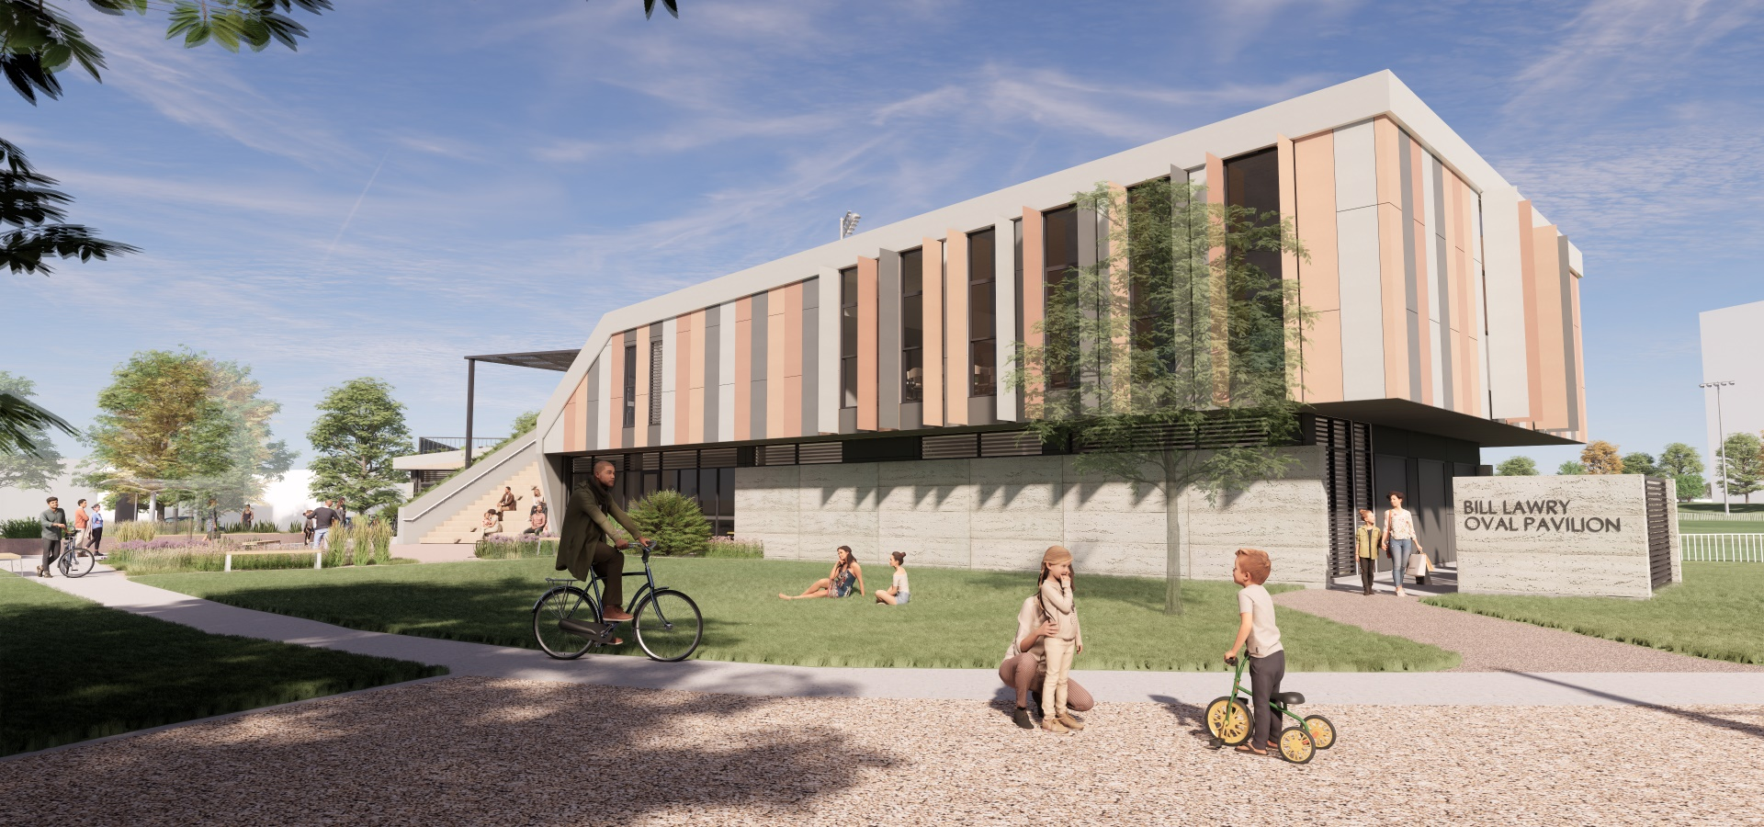

Bill Lawry Oval Pavilion Redevelopment
Draft concept design feedback summary
November 2021

In October 2021 we shared the draft concept design for the new Bill Lawry Oval Pavilion. We heard lots of positive comments on the new design. We heard that some of the things people like about the new design are:
- Improving the connection between Bill Lawry Oval and Oldis Gardens through the new pavilion design is a welcomed move.
- The architecture is contemporary and welcoming.
- Removing the perimeter fence that is currently around the oval is a good idea as it deters some community members from using the oval for general recreation and exercise.
- It looks like it will be a wonderful place to visit and will encourage people to frequent the oval more often.
- The grassy mound was well received with many people seeing the area as a great place for a picnic and to watch the game.
- The green roof is a great way to make the new building blend into the environment.

The below table summarises some of the other key themes we heard from the consultation and communicates how we have responded to this feedback in finalising the design.
What we heard… | Our response…
The chain mesh fencing around the perimeter of the oval is rusted, uninviting and makes some people feel as though the oval can not be accessed for general recreational use. | We will be removing the perimeter fencing as part of the redevelopment and it will not be replaced. The oval will remain unfenced, improving the connection to Oldis Gardens and removing the visual barrier that we know discourages some people from accessing the oval for general leisure.
The white picket fencing around the oval is well loved. | There is no change to the white picket fencing around the oval. It was stay in place as it is.
The bluestone retaining wall on Westgarth looks like it is crumbling and doesn’t looked well maintained. | We will be deconstructing and rebuilding the bluestone wall as part of the project to improve its structure and to improve its appearance.
This is a great opportunity to reflect local indigenous culture in the new building. | We have been working with Wurundjeri elders on a design to represent indigenous history into the design. We love what we have collectively come up with and will share it with you once it is formally approved by the Wurundjeri Woi Wurrung Cultural Heritage Aboriginal Cooperation.
There are some concerns about the demand for car parking that may increase when the new pavilion opens. | The new pavilion is approximately the same size as the existing facilities and will accommodate the same types of users. We expect that demand for car parking will stay the same as it is now and that there won’t be a large increase sparked by the redevelopment. As such, no new car parking is included as a part of the project.
A small number of community members would like to see the existing grandstand stay. | The grandstand is at the end of its structural life and it is no longer fit for purpose. The heritage value of the grandstand, which is as a place of community gathering, will be retained in the new pavilion design with the grassy viewing mound, social room balcony and seating bleachers providing plentiful opportunities for people to come together and watch the action on the oval.
Providing gym equipment and fitness tracks around the oval and the surrounds would be a great way to encourage greater recreational use. | We will take this feedback on board in planning for the wider precinct. The scope of the pavilion redevelopment includes the new buildings and the landscaping immediately around it.
The proximity of the new building to Merri Creek is important and the design should feature indigenous plant species. | The new garden beds in the entrance forecourt will feature a number of different indigenous plants including Pigface, Australian Bindweed, Chocolate Lily, Wooly Tea-tree, Native Flax, Austral Crane’s Bill and more.
Having external spaces to view the action on the oval is important. | The new design will offer several great locations to watch the play including from standing bleachers near the home change rooms, from the social room and its balcony, from the tiered seating bleachers and from the grassy mound. Spectators will also be able to enjoy shade from new trees that will be planted on the Westgarth Street embankment.
Ensuring all members of the community can enjoy the new pavilion is important and the design must be accessible. | The pavilion design has been critically reviewed by an equal access consultant to ensure that it is able to be enjoyed by users with a range of different needs.  Importantly, as part of the redevelopment we will be creating a disabled car parking space on the street at the main entrance (just to the west of the bus stop)/
There are lots of questions about how the social space will operate as a hirable facility. | KATHIE TO RESPOND.

